# Thermal Calculations

Figure X shows the schematic of junction temperature without heatsink. Also, junction – case thermal resistance should be added to the system.

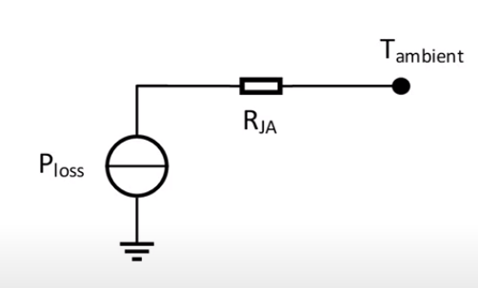

Figure X . Schematic of Junction Temperature without Heatsink

Figure Y shows the schematic of junction temperature with heatsink.

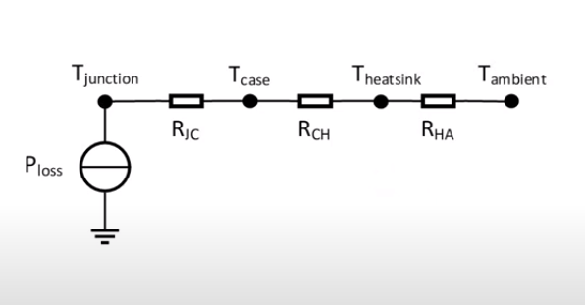

Figure Y Schematic of Junction Temperature with Heatsink

Junction temperature without heatsink can be calculated with equation XXX and junction temperature with heatsink can be calculated with YYY. Moreover, if lower junction temperature is needed, heatsink can be used. Required thermal resistance for heatsink can be calculated as in equation ZZZ.

|  |  |
| --- | --- |
|  | XXX |
|  | YYY |
|  | ZZZ |

## MOSFET

Ambient temperature is assumed as 25°C and junction temperature is calculated as follows. When **RDS** is0.50Ω, calculated maximum power loss is 0.54 W.

|  |  |  |  |
| --- | --- | --- | --- |
| RthJA,TYP - RthJA,MAX: 35°C/W - 62°C/W | | | |
| **RDS** | **Assumed TJ** | **Max. Power Loss** | **Calculated max TJ** |
| 0.50Ω | 25°C | 0.54 W | 58°C |
| 0.60Ω | 58°C | 0.57 W | 60.3°C |
| 0.61Ω | 60.3°C | 0.58W | 61°C |
| 0.61Ω | 61°C | 0.58W | 61°C |

The most important feature of the MOSFET we use is that it causes low losses. R**ds** value is both very low and its value does not change much with increasing temperature, also low losses have been obtained due to low current values in the primary side. Thanks to all this, no heatsink is required for the MOSFET since MOSFET can operate up to 150°C .

## Diode